Step1- Created a new job – named as Job 4

Steps2- attached a dedicated slave to deployment as of now to deploy the web app on node (i.e which is Test Server ).

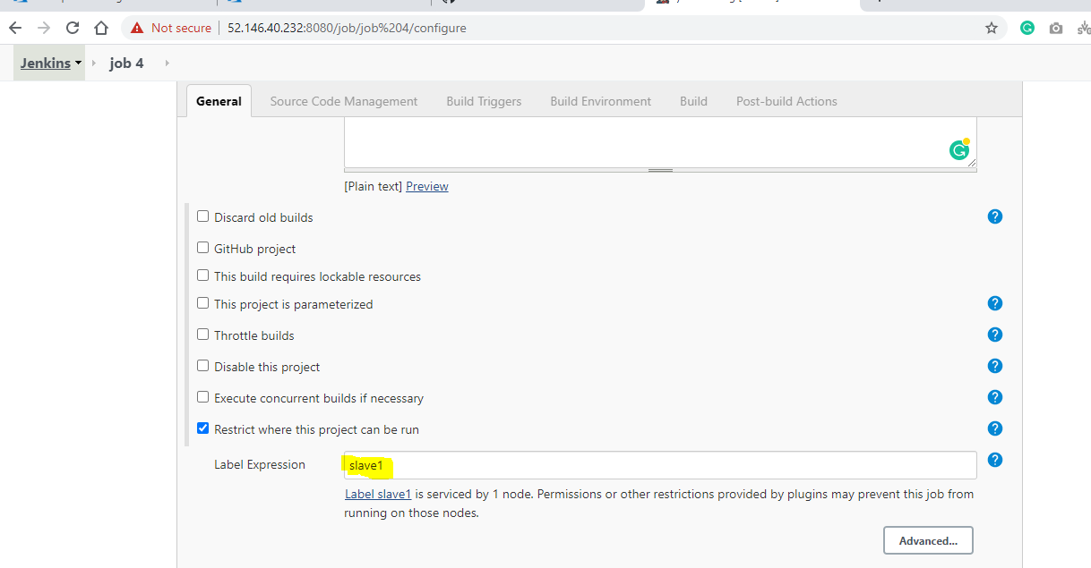

Step3- added a public Git repo and specified the branch as well which is dev for Test Server

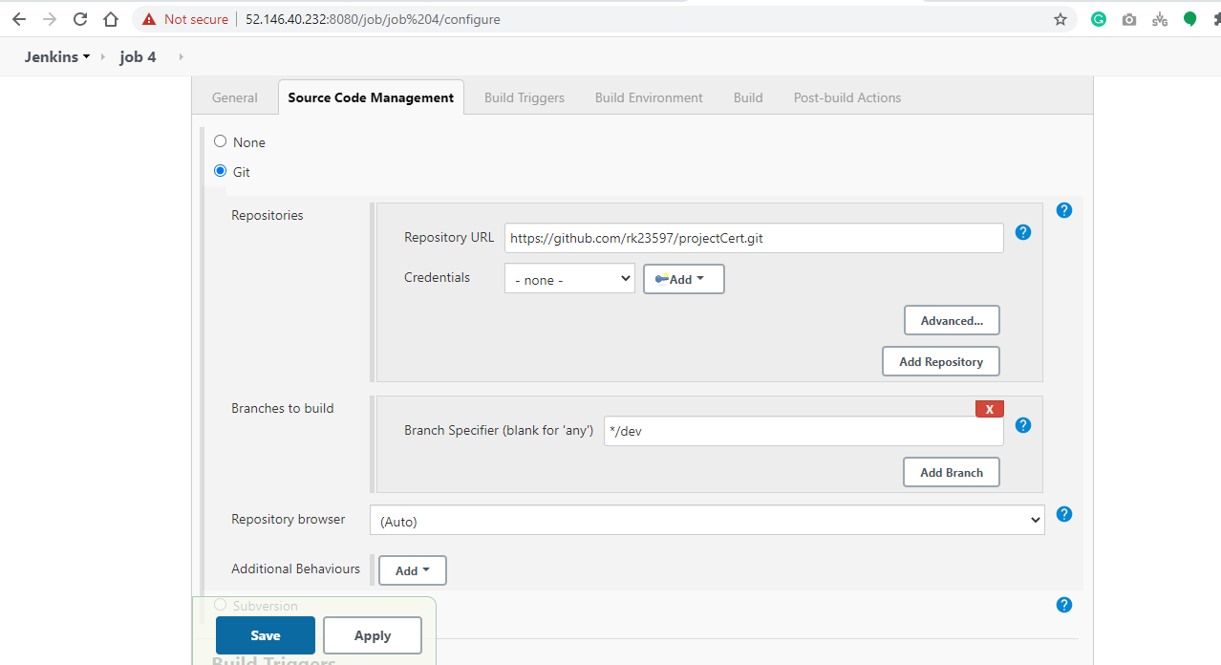

Git URL - <https://github.com/rk23597/projectCert.git> , having 3 branches i.e. dev , staging , master

1. Dev branch is for development
2. Staging branch act as pre-prod
3. Master branch is containing production code

Step4 – Git repo contains the web app code and docker file.

In Build section – written the shell code to build the docker file and tag it and deploy the docker image to test server.

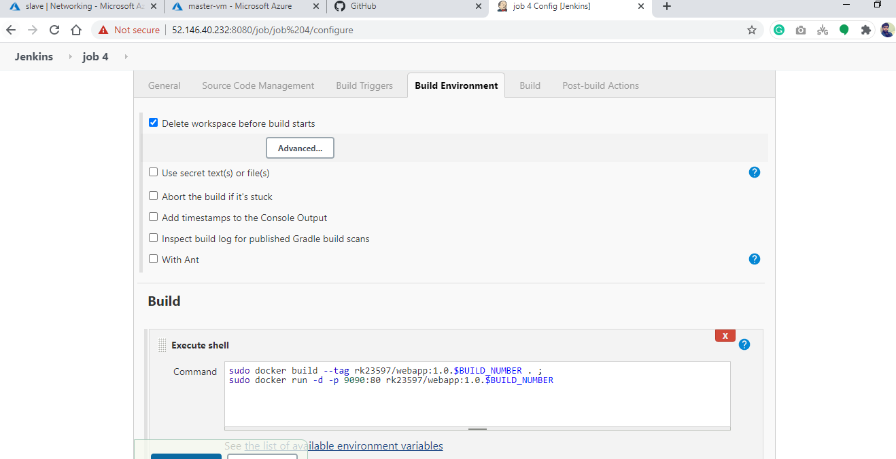

Naming convention – rk23597/webapp:1.0.$BUILD_NUMBER

rk23597 is docker username and webapp is image name and 1.0.$BUILD_NUMBER is version of image.

Step5 – if build fails then stop the running container on test server.

If build fails then job5 will trigger automatically to stop the running containers.

